Sprint-3

Application Building

RUN THE APP

|  |  |
| --- | --- |
| Date | 11Nov 2022 |
| TeamID | PNT2022TMID09796 |
| ProjectName | Classification of Arrhythmia by Using Deep Learning with 2-D ECG Spectral  Image Representation |

TASK:

*Run The App.*

RUN ON LOCAL HOST (SCREEN SHOT):

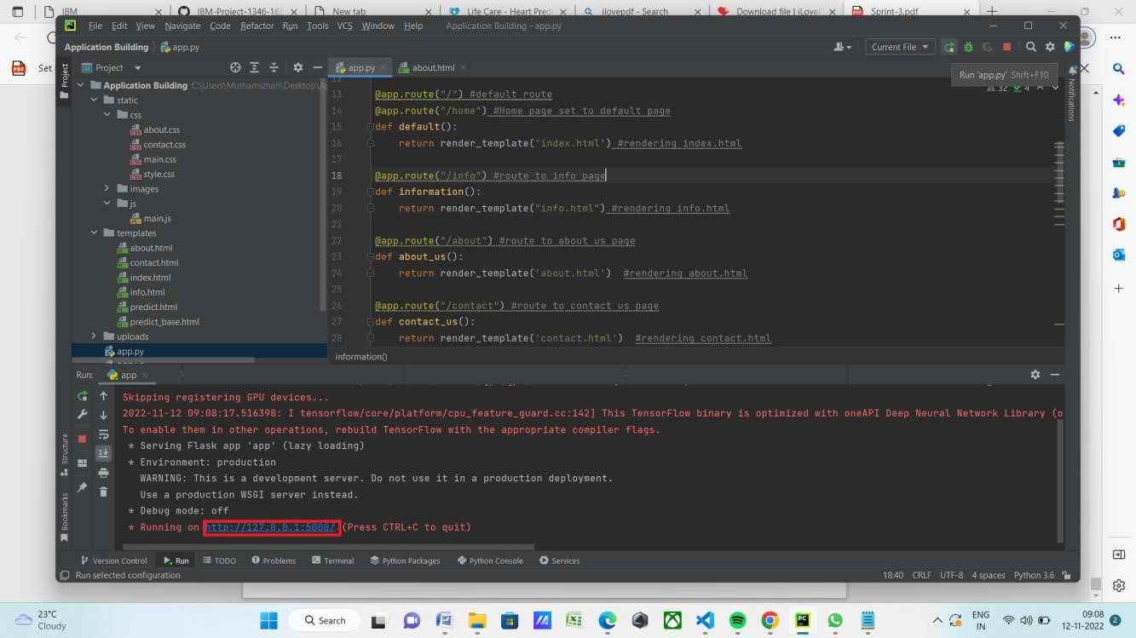

LOCAL HOST:

CLICK PREDICT (SCREEN SHOT)::

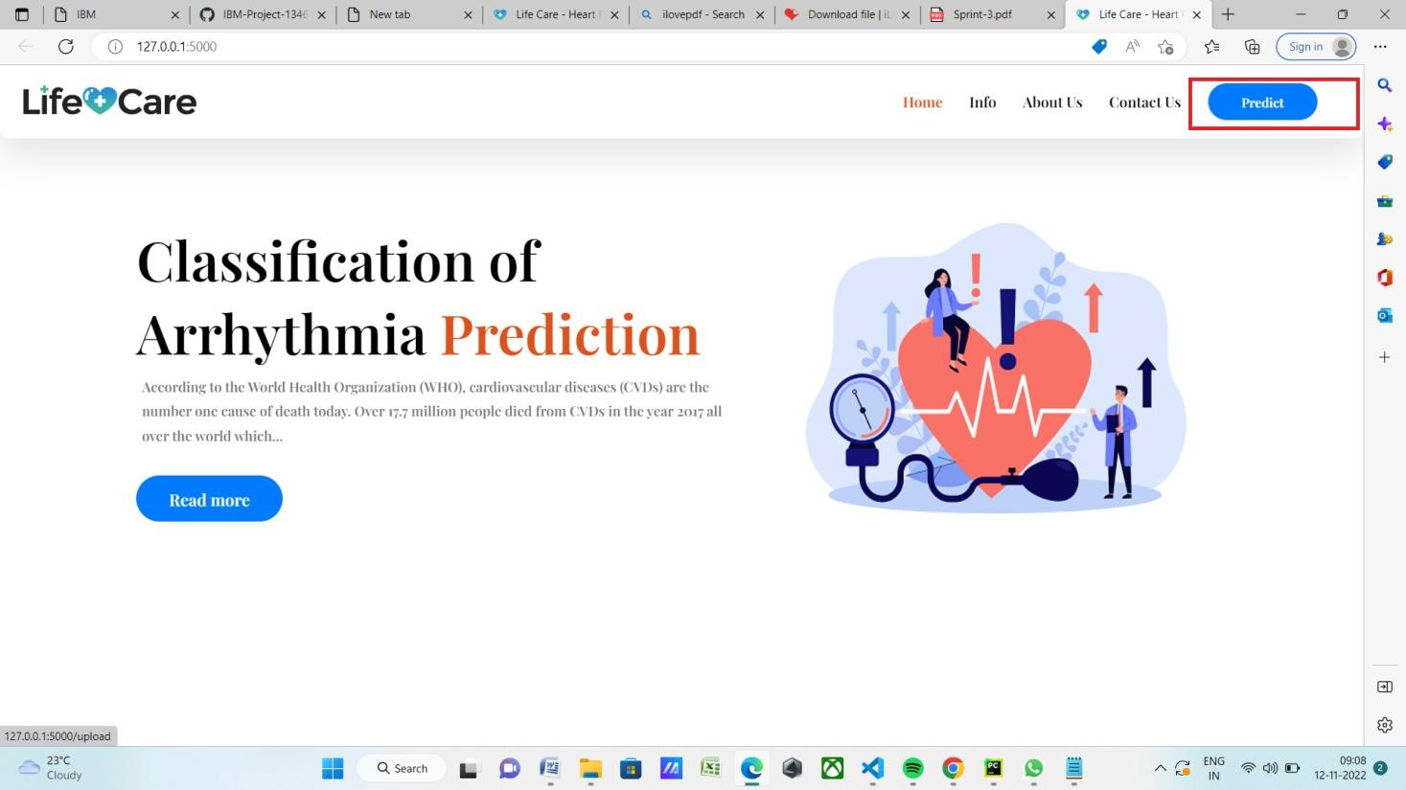

CLICK CHOOSE BUTTON (SCREEN SHOT):

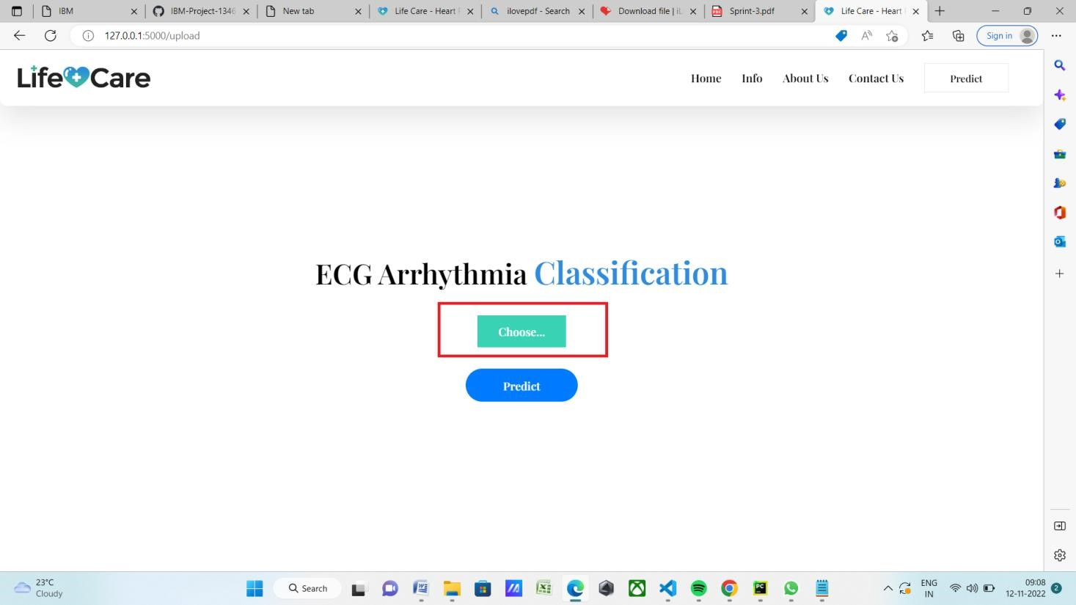

GO TO UNKNOWN FILE (SCREEN SHOT):

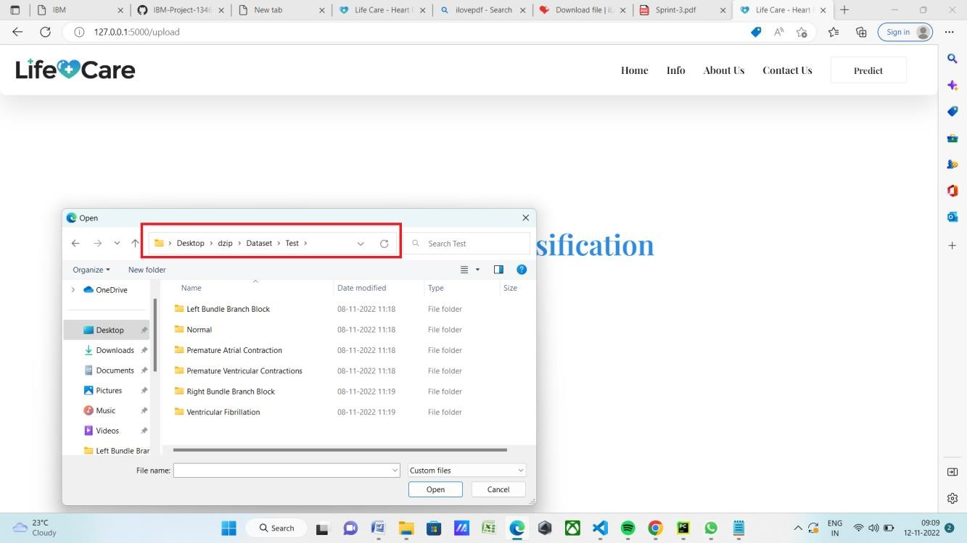

SELECT ANY FILE (SCREEN SHOT):

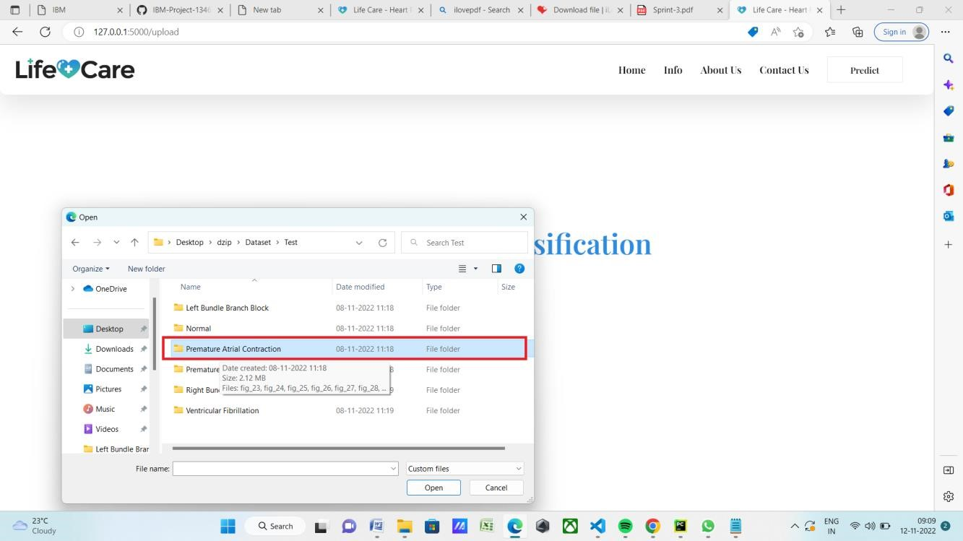

CLICK ANY ECG PHOTO (SCREEN SHOT):

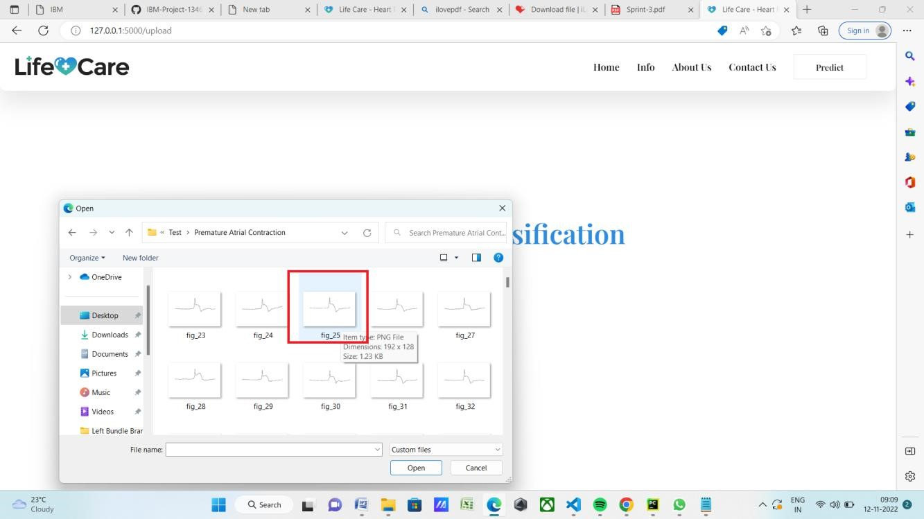

CLICK PREDICT BUTTON (SCREEN SHOT):

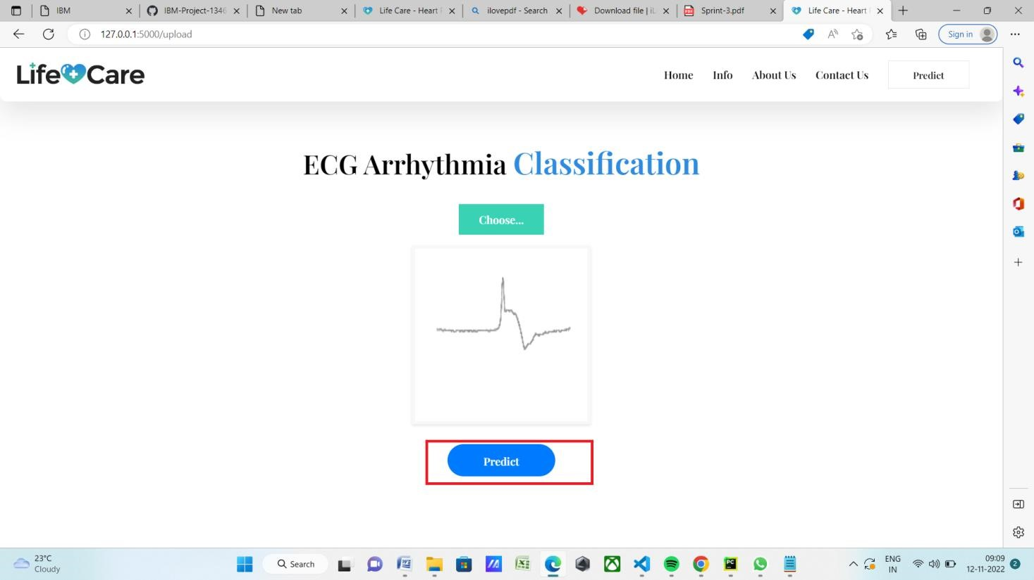

SHOW ON RESULT (SCREEN SHOT):

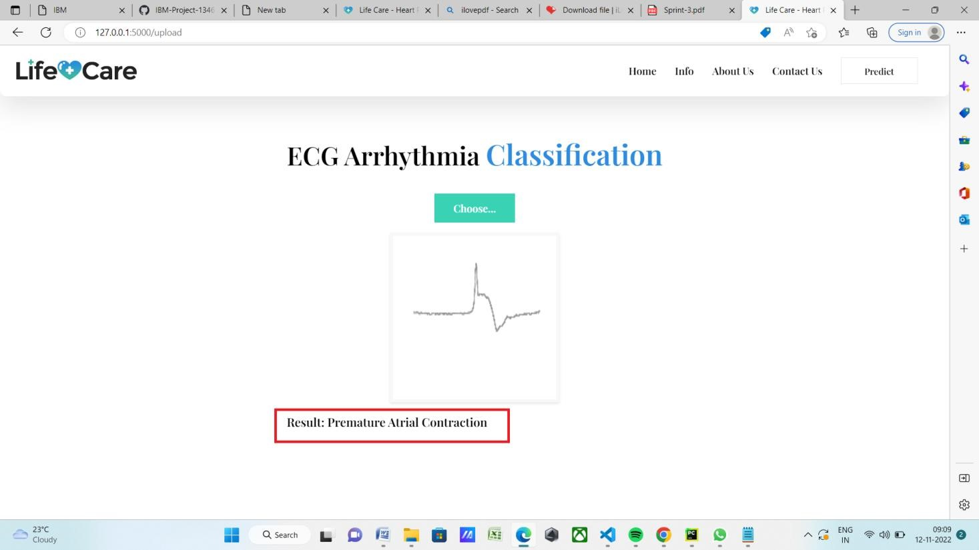

PREDICT THE CORRECT RESULT